**POTENTIALS OF URBAN GARDENS**

**Student:** Name and surname

Supervisor: Name and surname

Name of School, Institution ...

author's contact email

1. Introduction

The introduction should include: the research area, other authors' data that were used for their own research or were the subject of verification; the aim of the research, i.e. the questions to which the paper, i.e. the author/authors, will answer. It should introduce readers to the following text in a harmonious and accessible way. An important part of the introduction is the overview of earlier works. In this way, the idea of the work and the goal of the research are connected with what was done before, so that the reader can understand what the research knowledge is based on.

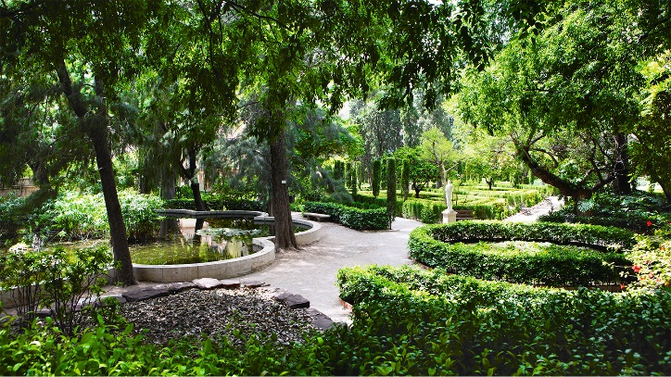

2. Problem analysis

Тhrough research to see: strengths, weaknesses, opportunities, threats...

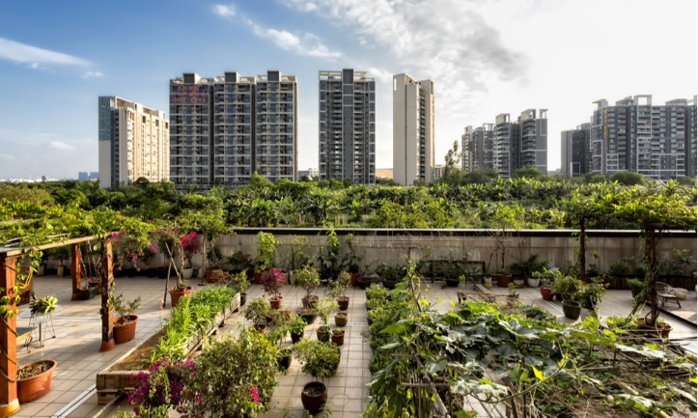

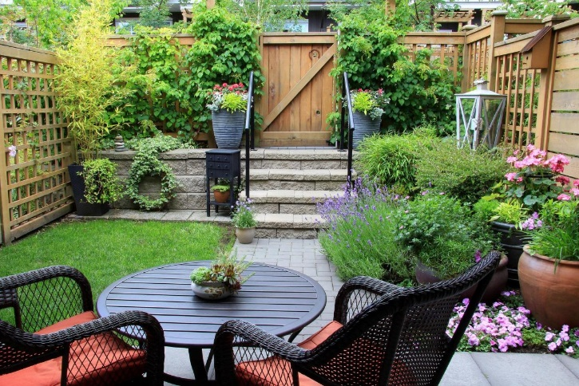

3. Result of work

State and describe the research results

4. Proposed solution to the problem

/ Own suggestions for solving the problem/

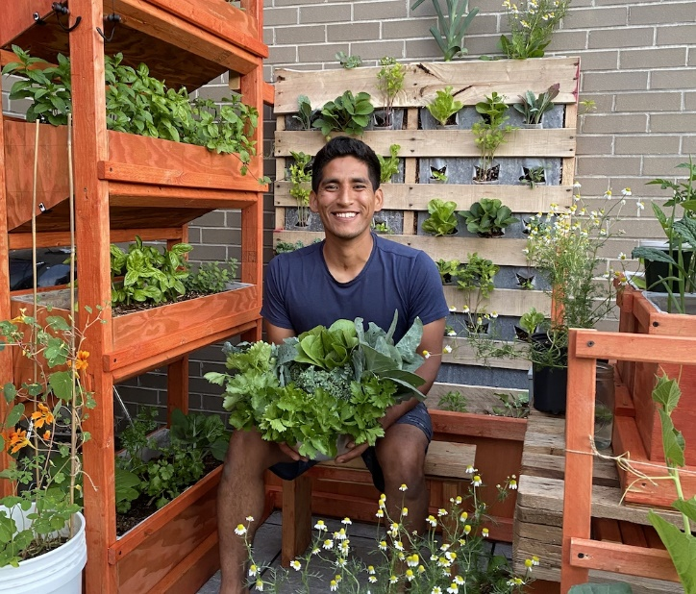

5.References

The sources used by the author in the preparation of his work are entered in the list of references(magazines, books, anthologies, studies, manuals, internal documents, static materials, etc.). The bibliography is listed in the order of appearance of the author in the work with appropriate numbering, in Arabic numbers.

When you cite an Internet presentation as a source, cite it separately. Provide the exact link to the location from which you downloaded the content, not as the address of the main page (www.google.com, for example).



